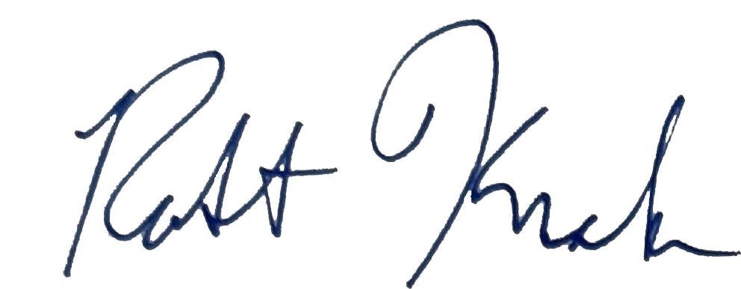
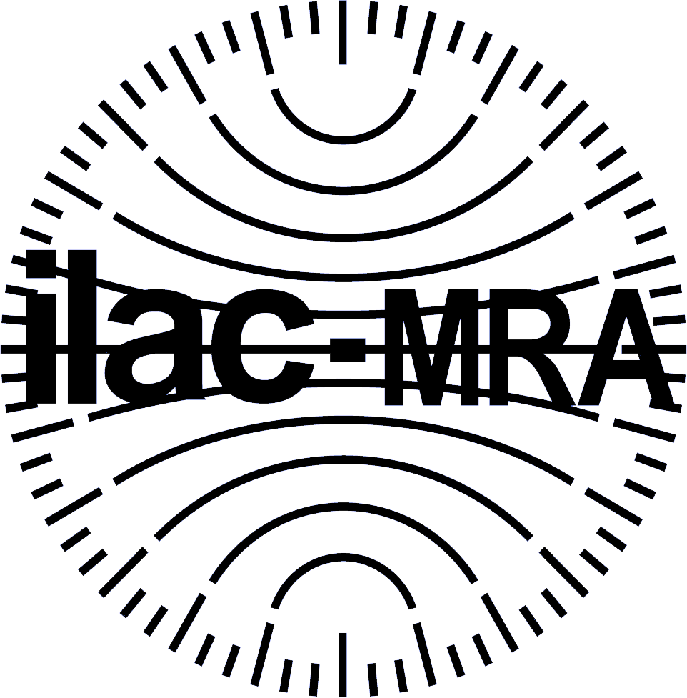
United States Department of Commerce National Institute of Standards and Technology

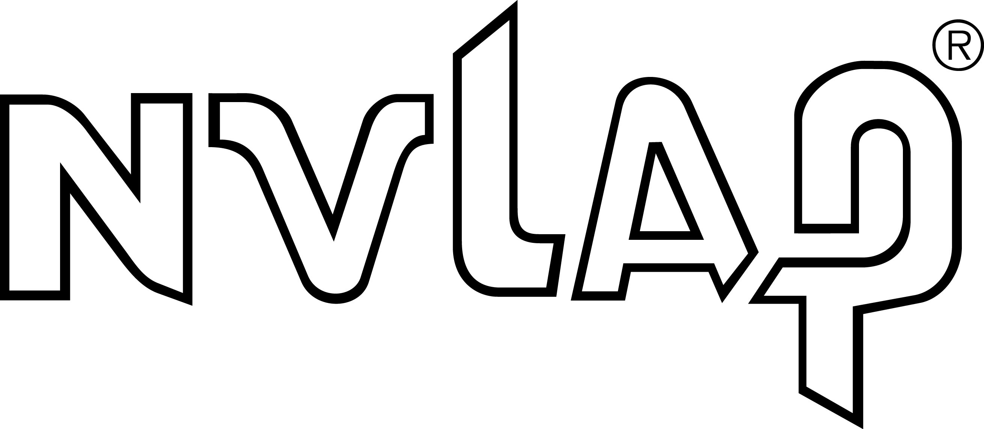

Certificate of Accreditation to ISO/IEC 17025:2017

NVLAP LAB CODE: 200127-0

David L. Ellis Co., Incorporated
Acton, MA

is accredited by the National Voluntary Laboratory Accreditation Program for specific services, listed on the Scope of Accreditation, for:

Calibration Laboratories
This laboratory is accredited in accordance with the recognized International Standard ISO/IEC 17025:2017.
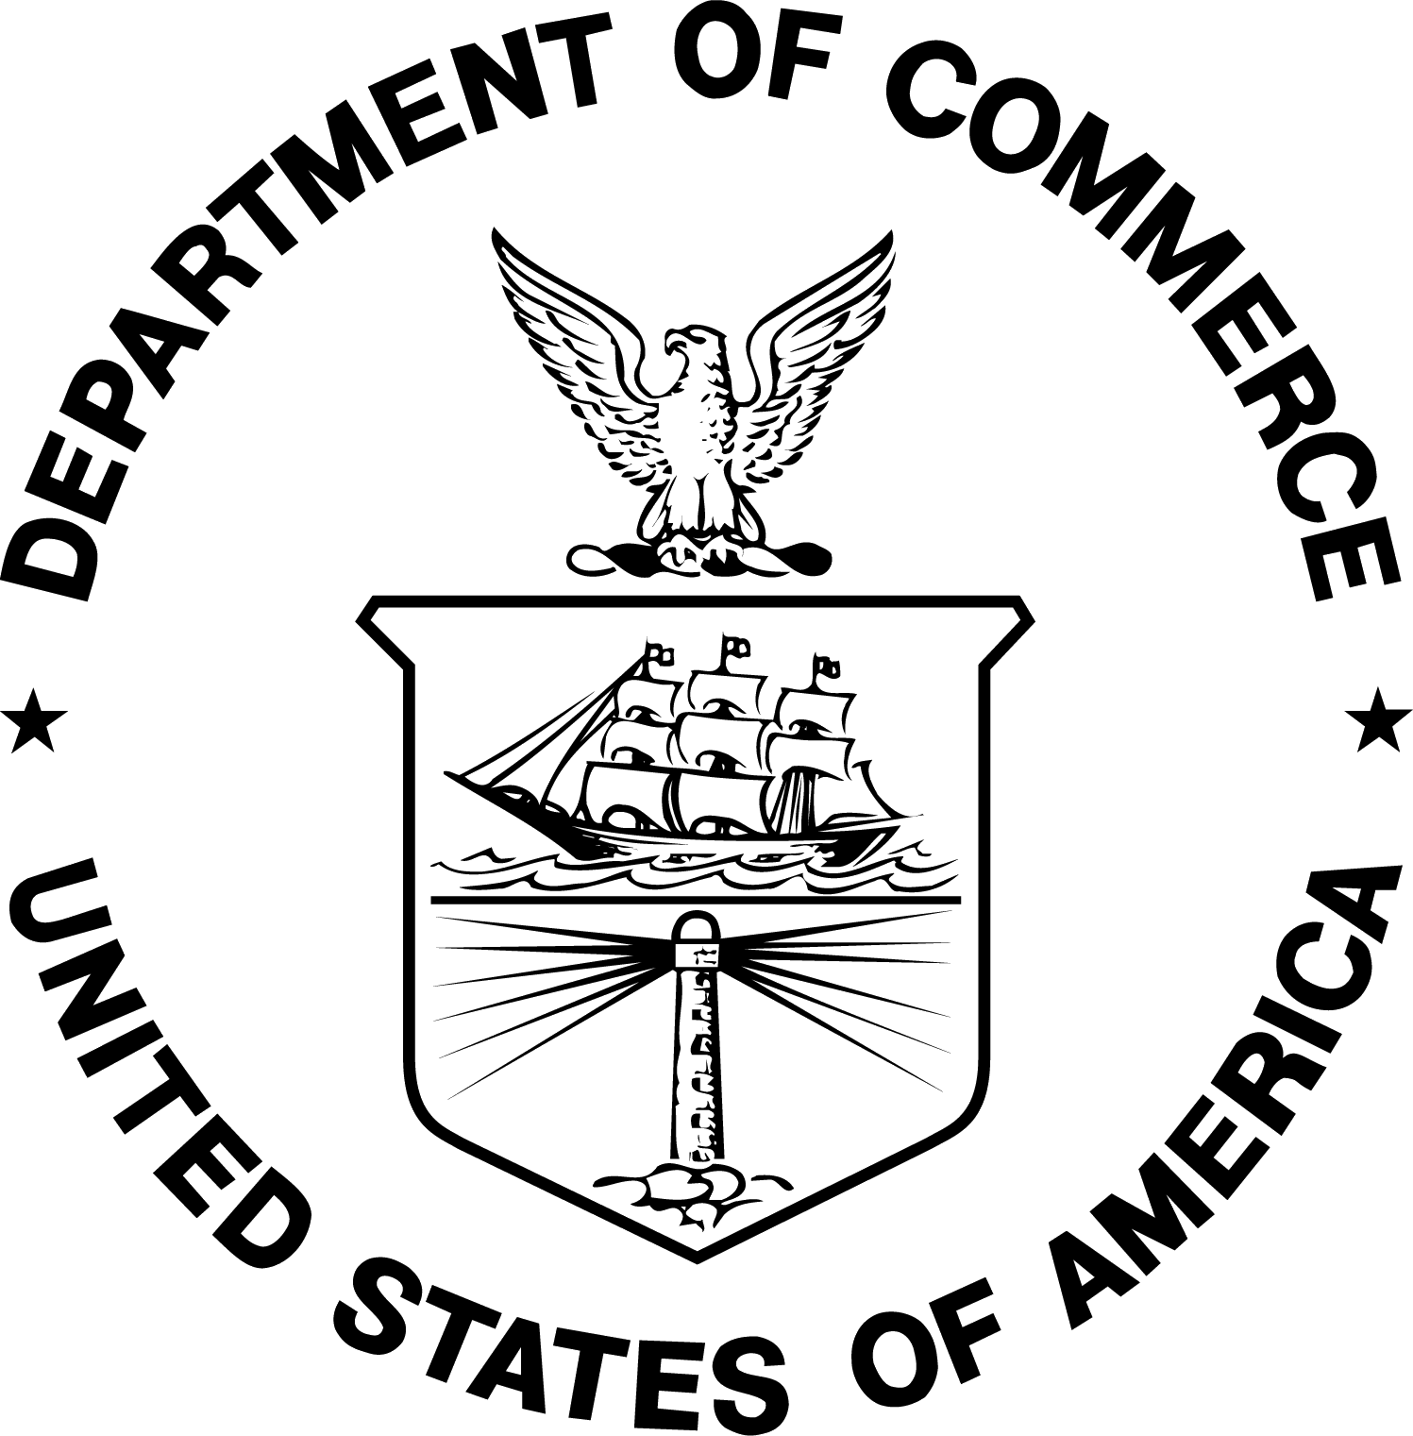
This accreditation demonstrates technical competence for a defined scope and the operation of a laboratory quality management system (refer to joint ISO-ILAC-IAF Communique on ISO/IEC 17025).

2026-09-11 through 2027-09-30

Effective Dates For the National Voluntary Laboratory Accreditation Program

